Ryder Cup style

with three formats changing every six holes -

(4 Man ABCD blind draw)

Wednesday August 15, 2012 9:00 Shotgun start

Entry Fee: $30.00 + cart

RULES:
- Ft. Lauderdale Scramble
- Seminole 7-9 and Choctaw 1-3 Lone Wolf (Scramble)
- Choctaw 4-9 Step Aside Scramble
- USGA rules apply
- No gimmies – the ball must be holed out no matter how short the putt

SCORING:
- Seminole 1-6 Ft. Lauderdale Scramble. Each Player will hit his drive and the captain will select the best drive for the team to use. Each player will hit the second shot and the captain will select the ball to be used. This will continue until a ball is holed out. If you choose a ball in a hazard, all must play from the hazard. Max of 3 drives per player. Min of 1 drive per player
- Seminole 7-9 and Choctaw 1-3 Lone Wolf scramble: Everyone will hit their drive on every hole. After the drive one player will be selected to play their own ball recording their gross and net score for that hole. The remaining three will select one other ball and play a three man scramble recording the gross score for that hole. Add the net score for the Lone Wolf and the gross score of the scrambling partners for the team score. All players must play own ball on one occasion, No player can play their ball more than two times.
- Choctaw 4-9 Step Aside Scramble; 4 man step aside from tee to hole. Record the score in the Team score box. Partners may place the ball within one club length of the ball selected, except on the putting green, within 6 inches. If the ball is in a hazard/ bunker the partners ball must be placed in the hazard or relief taken based on the ball in the hazard. Neither can be closer to the hole
- Ties will be broken by scorecard playoff using the aggregate of 4 lowest handicap holes and then working backwards from the #5 handicap hole, etc. until a winner is determined
- Handicaps at 90%

PRIZES:
- Number of winners of pro shop credits TBD based on numbers of entries.

LUNCH:
- Lunch will be served in the main dining room immediately following completion of play,

PROCEDURE FOR THREESOMES:
- Let the committee know if you only have three players to receive the procedures document.

TOURNAMENT COMMITTEE: Don Smith, Bill Armstrong
SMGA Ryder Cup Tournament

Procedure for Threesome

Ft. Lauderdale Scramble
- Starting on Seminole #1 - One player will hit two drives on the first hole ( Player hitting two tee shots must be rotated in the order listed on the scorecard). The second player will hit two second shots, and the third player will hit two third shots. This rotation will continue throughout the round.

Lone Wolf format

.
- Starting on Seminole #7 – The team selects player who will be the lone wolf on each hole AND play a second ball in the scramble. ( Player hitting two tee shots must be rotated in the order listed on the scorecard).
- Max drives 3, Min drives 1

Step Aside format
- Starting on Choc #4 - The Lowest handicap player tees off using two balls. Whoever hit the ball selected to play steps aside. Of the two remaining players, the one with the lowest handicap plays two balls. Whoever hit the ball selected to play steps aside. Of the two remaining players, the one with the highest handicap plays two balls.
Continue this until the scoring ball is holed.

- On the Choc # 5 tee- the second lowest handicap player tees off using two balls. Whoever hit the ball selected to play steps aside. Of the two remaining players, the one with the lowest handicap plays two balls. Whoever hit the ball selected to play steps aside. Of the two remaining players, the one with the highest handicap plays two balls.
Continue this until the scoring ball is holed.

- On the Choc #6 tee - the third lowest handicap player tees off using two balls. Whoever hit the ball selected to play steps aside. Of the two remaining players, the one with the lowest handicap plays two balls. Whoever hit the ball selected to play steps aside. Of the two remaining players, the one with the highest handicap plays two balls.
Continue this until the scoring ball is holed.

- Repeat for Choc #7,8,9
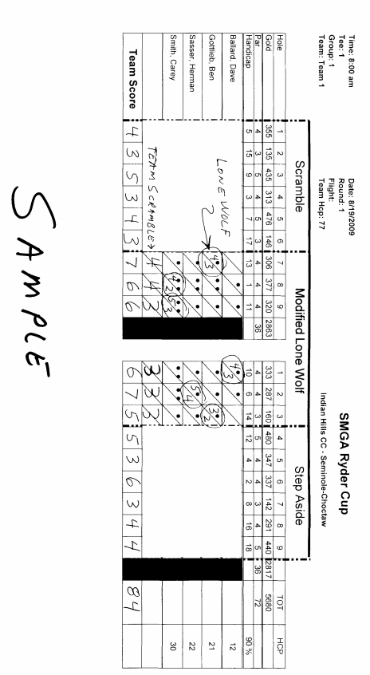
Hints and Tips
- Obtaining door prizes are at your team’s discretion. If you have a lot of door prizes you should develop a way to quickly distribute them to move the session along in the shortest amount of time.
- The scorecard used is specially designed for this tournament. Inform the Golf Professional you are working with to use it. Contact Dave Ballard if there are any questions on this card.
- Sample Scorecard was key to keeping score properly. As was posting a sign on the tee box when the format changed.
- Have a few copies of the threesome procedure available to give out. No need for everyone to have one.

IHSMGA Tournament Report

Tournament Name:

Tournament Date:

Number of participants:

List of winners and payouts:

Meal Details:

Problem Areas:

No Shows:

Any suggestions for change or improvement:

Send to Tournament Director with the Financial Report, pairings

